**Assignment – Cloud Computing**

**Creating Instance On Aws**

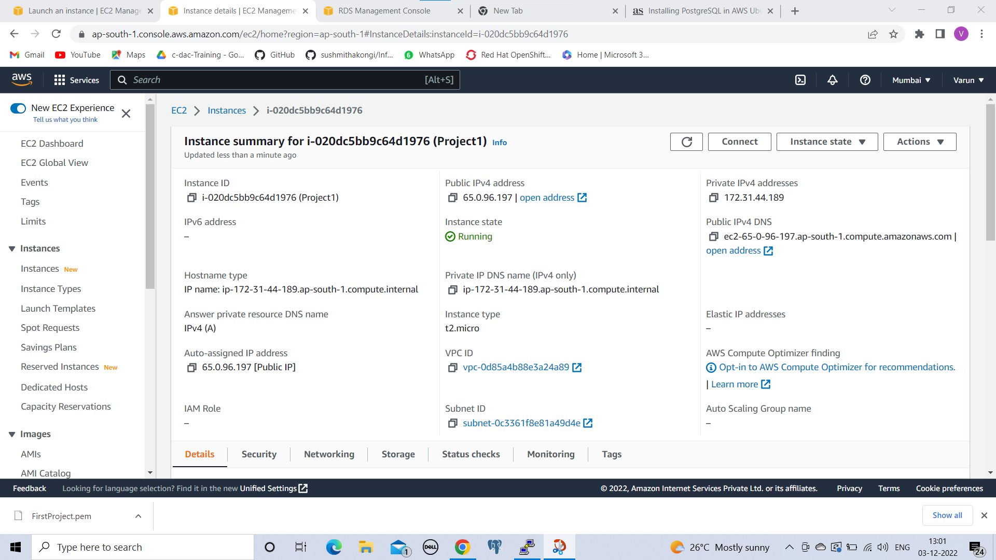

**Putty Generator private key loading**

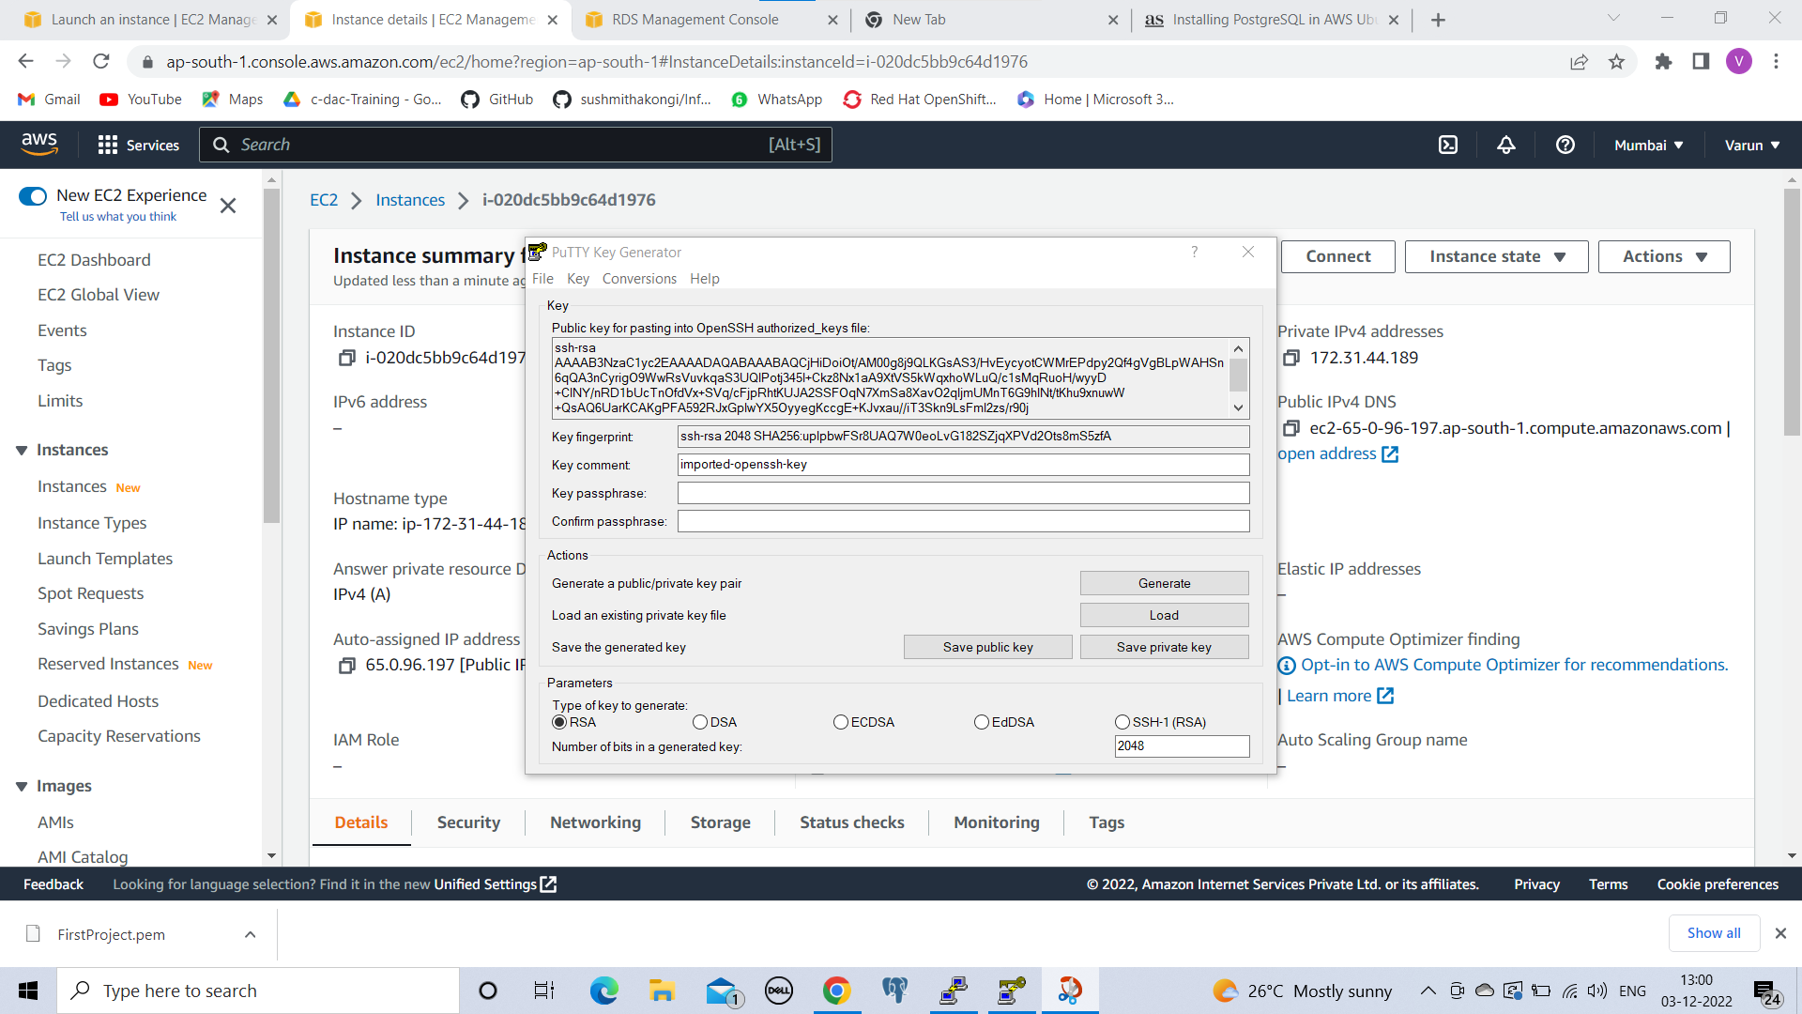

**Connecting To The Server With Putty**

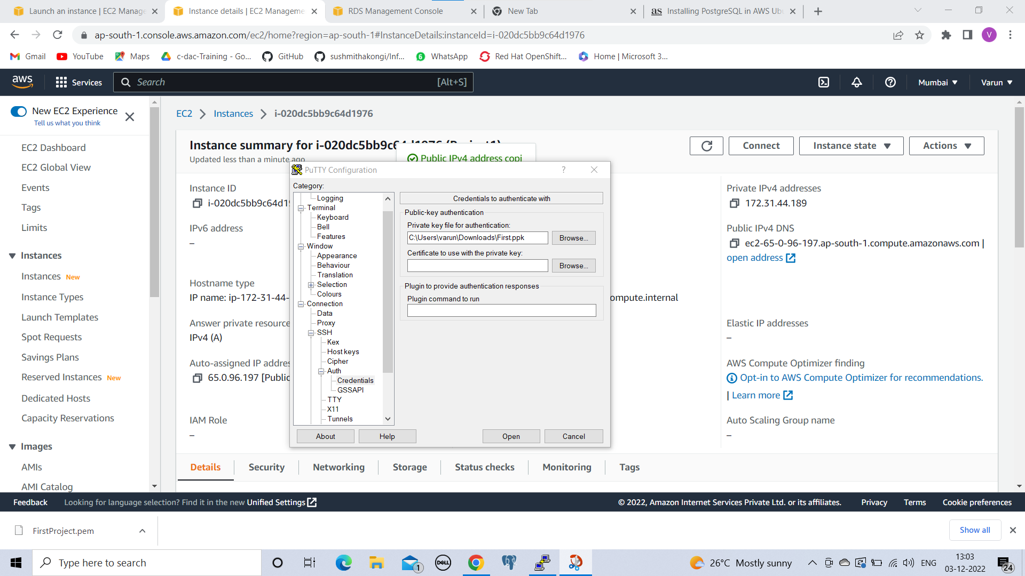

**Logging in Ec2-Instance:**

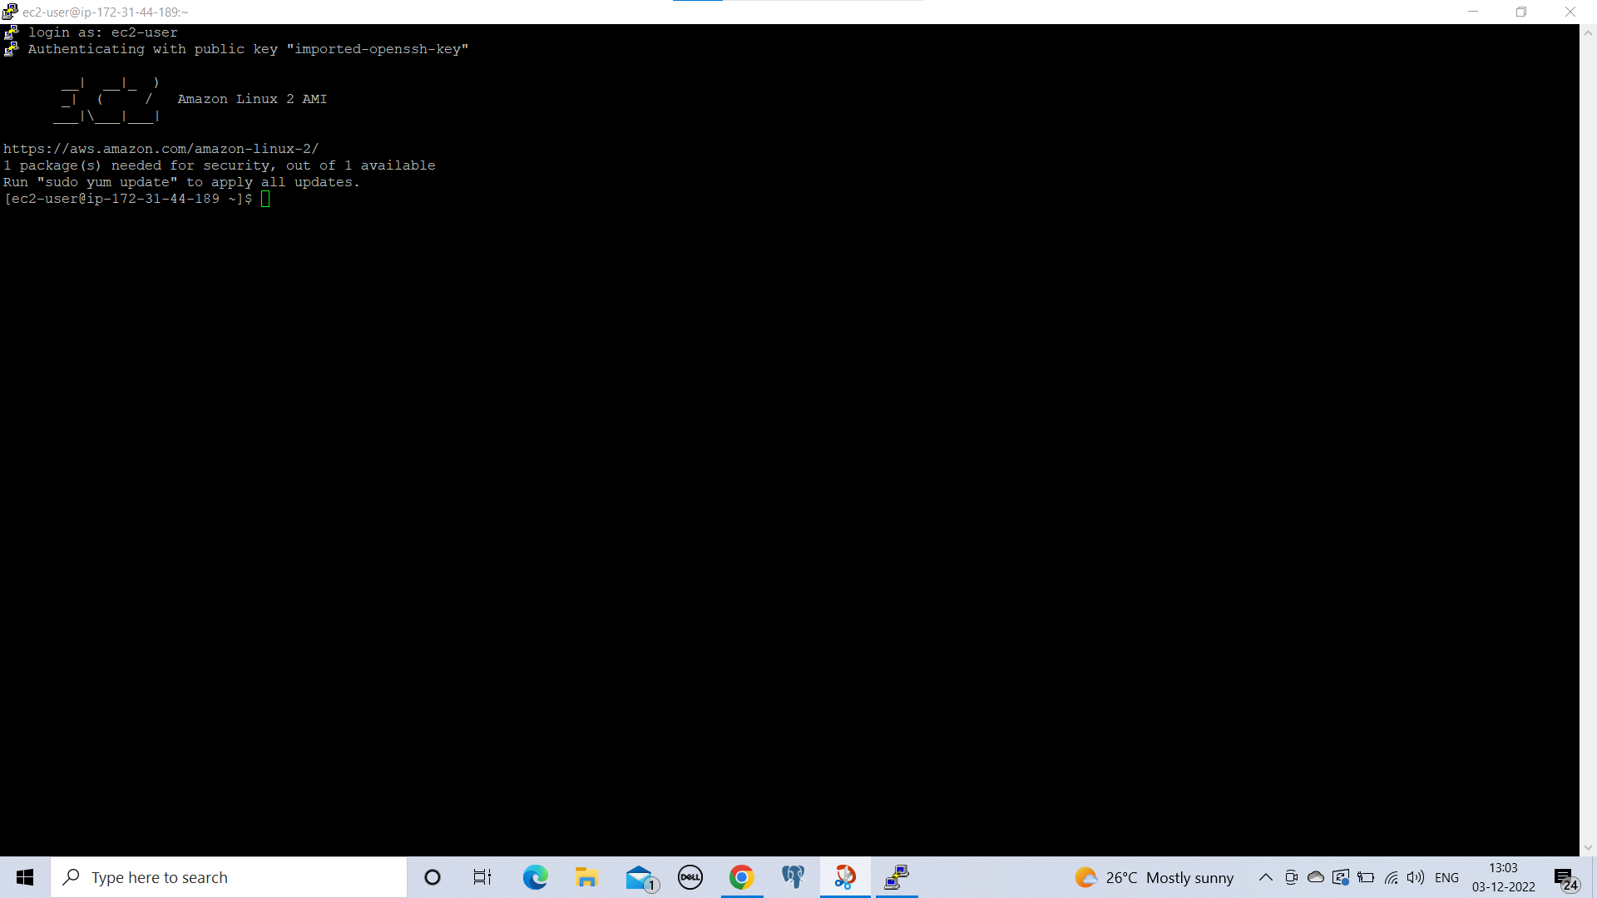

**Uploading the File To the Instance from FileZilla**

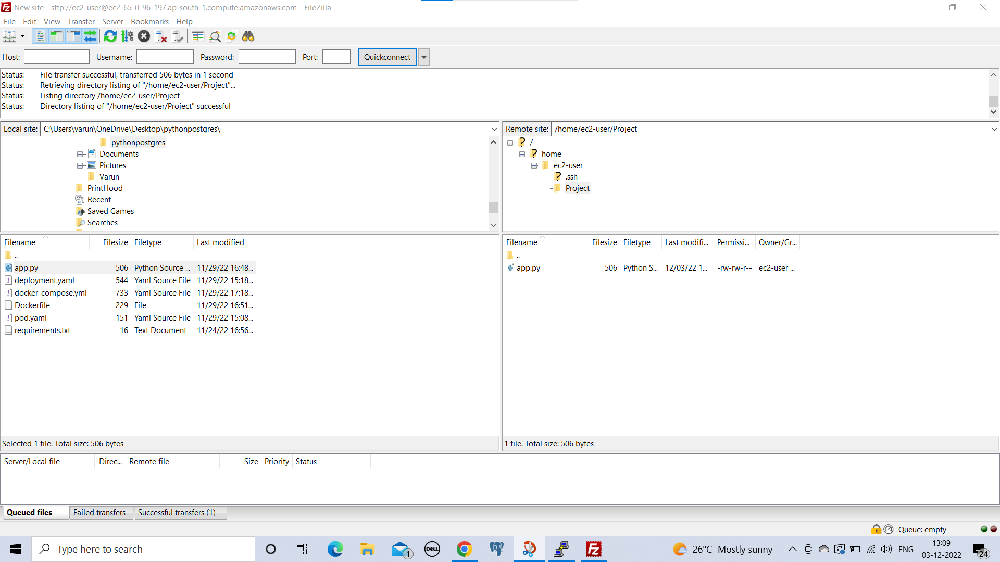

**Running sent file from filezilla on ec2 instance**

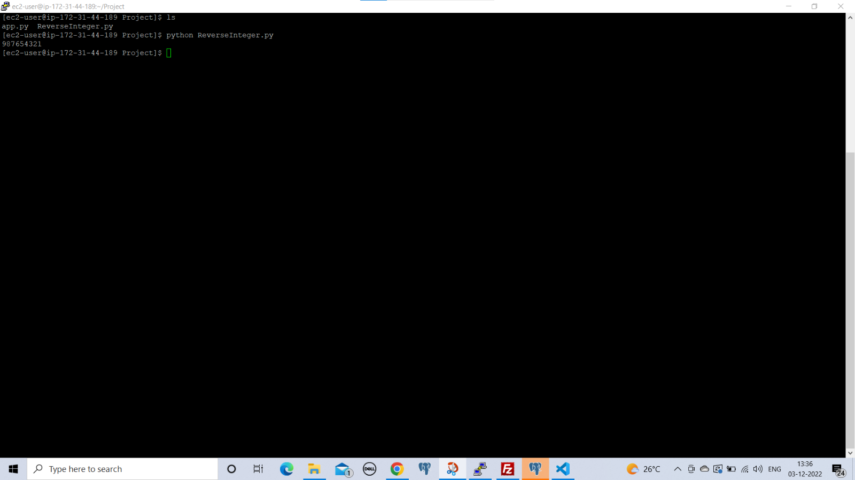

**Creating RDS on aws**

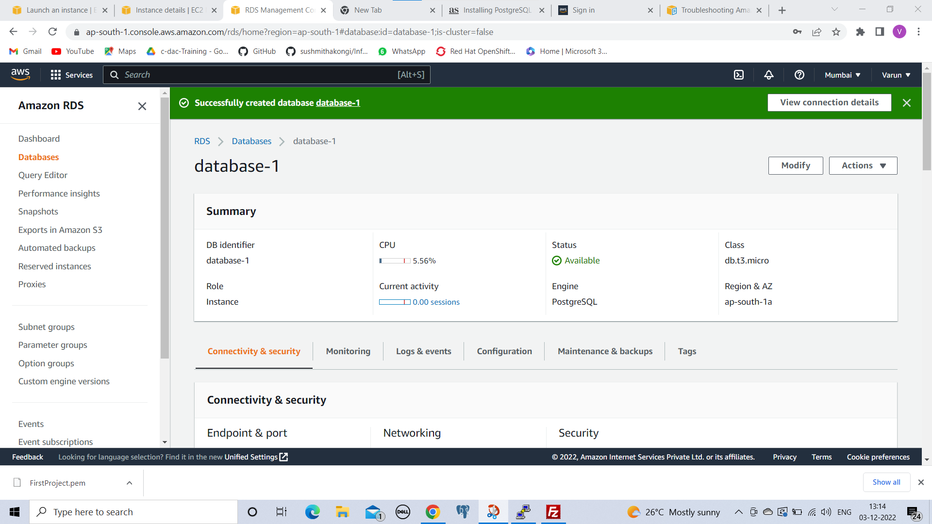

**Conneccting RDS to the Pg-Admin**

